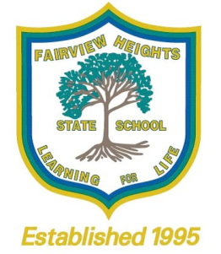
Refund Policy
At Fairview Heights State School, we are committed to providing a safe and supportive learning environment for students, staff and volunteers. This commitment includes the health and safety of staff and students when conducting curriculum activities in the school or in other locations.
School excursions and camps enhance a student’s learning by providing opportunities for the student to participate in activities, both curriculum-related and recreational, outside the normal school routine. All planned school excursions are approved by the Principal and endorsed by the Parents and Citizens Association.
State schools are able to charge a fee for:
- An educational service including materials and consumables not defined as instruction, administration and facilities for the education of the student;
• An education service purchased from a provider other than the school where the provider charges the school; and
• A specialised educational program.
A school fee is directed to the purpose for which it is charged.
School fees for excursions and camps are calculated on a cost recovery only basis, according to the number of students who have indicated their attendance.
Participation of students in an excursion or camp is indicated through payment of the excursion or camp fee and provision of a permission form completed by the parent/carer.
As the school budget cannot meet any shortfalls in funding for an excursion or camp due to the subsequent non-participation of a student who had previously indicated attendance of the activity, fees already paid for an excursion or school camp may be refunded in full or in part or not at all, having regard to the associated expenses incurred and the circumstances of the non-participation.
In special circumstances, performance based excursions have a NO refund policy. This will be noted on the Excursion Information letter.
If a parent/carer wishes to apply for a refund due to their child’s non-participation in an excursion or camp activity, they may do so by completing a ‘Request for Refund’ form available from the school office. Where possible, the request should include the receipt relating to the payment for which a refund is being sought.
It is preferred that refunds be made as a credit against the student’s account at the school, and used for any cost in the future.
Fairview Heights State School’s refund policy for amounts of $20 and under, is to credit the student’s account automatically. However, a parent may still apply for a refund by other means by completing a ‘Request for Refund’ form. Refunds for amounts over $20 require a ‘Request for Refund’ form to be completed.

Department of Education, Training and Employment policy references:
Education (General Provisions) Act 2006
SCM-PR-002: School Excursions
FNM-PR-019: State Education Fees

